**CS23333-Object Oriented Programming Using Java**

**NAME: ENIYA.B.A**

**ROLL NO: 230701085**

**WEEK-1: Java Architecture,Language Basics**

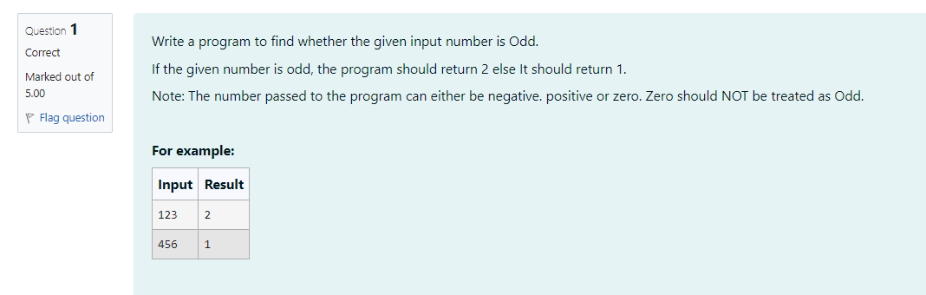

**CODE:**

import java.util.*;

public class Oddeven{

public static void main(String[] args){

Scanner sc=new Scanner(System.in);

int num-sc.nextInt();

if(num%2==0){

System.out.println("1");

}

else{

System.out.println("2");

}

}

}

**OUTPUT:**

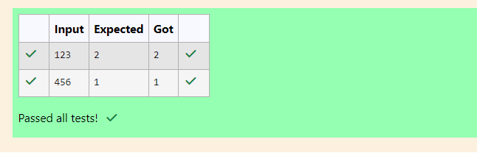

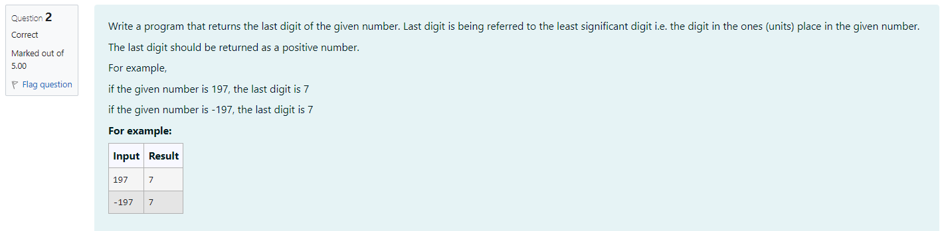

**CODE:**

import java.util.*;

public class LastDigit{

public static void main(String[] args){

Scanner sc=new Scanner(System.in);

int num=sc.nextInt();

int a-Math.abs(num);

int b=a%10;

System.out.println(b);

}

}

**OUTPUT:**

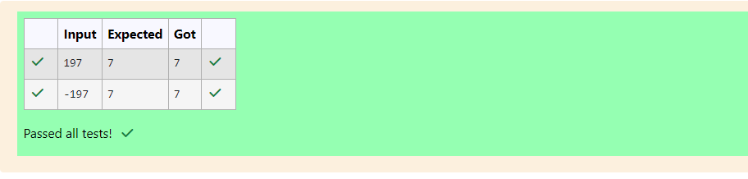

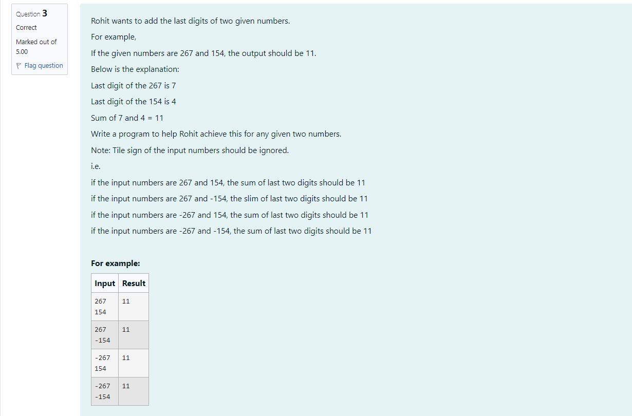

**CODE:**

import java.util.*;

public class AddLastDigit{

public static void main(String args[]){

Scanner sc=new Scanner(System.in);

int n=sc.nextInt();

int m=sc.nextInt();

int a-Math.abs(n)%10;

int b=Math.abs(m)%10;

int sum=a+b;

System.out.println(sum);

}

}

**OUTPUT:**

